

ABC Awards Level 2
Motor Vehicle Studies

Underpinning Knowledge Evidence Record

A/601/3732 Knowledge of Removing and Replacing Light Vehicle Chassis Units and Components

Learners Name
ABC Awards Registration Number
Centre Name
Assessor 1 Name
Assessor 2 Name

DECLARATION OF AUTHENTICITY

This declaration must be completed and signed by the learner and countersigned by the tutor / assessor and covers all evidence submitted for moderation.

Learner Name
Unique Learner Number (ULN) |  | ABC  Learner Reg. ID
Qualification Title
Centre Name

Learner statement of authenticity

Before signing please read the guidance below.

I confirm, that the attached assignment / portfolio is all my own work and does not include any work completed by anyone other than myself. I have completed the assignment / portfolio in accordance with ABC Awards’ instructions and within the time limits set by my centre.

Signature |  | Date

Centre confirmation of authenticity

On behalf of …………………………………….(insert centre name), I confirm that the above mentioned learner, to the best of my knowledge, is the sole author of the completed assignment / portfolio attached, and the assessments have been completed under the required conditions.

Signed |  | Date
Name
Title

Guidance for Learners

You have been asked to sign this Declaration of Authenticity and place it at the front of your portfolio or course work assessment. It confirms that the work you have submitted for assessment is your own and that you have not copied it from someone else or allowed another learner to copy it from you.

When preparing any course work it is good practice to undertake research using information from published sources. If you quote directly from these sources then this must be indicated in your work by using quotation marks and referencing the document from which the quotation was taken. You must then comment in your own words on any ideas expressed.

Assessors, internal verifiers and ABC Awards’ external moderators and verifiers are subject specialists who can spot the use of published materials that may be passed as your own words or ideas.
If you do copy words from a published source and do not indicate their reference you will be committing plagiarism. This is considered a form of cheating and may result in your assessment being declared void.
Contents

Task No | Title | Assessment Criteria
1 | Steering and suspension systems | 1.1, 1.2, 1.3, 1.4, 1.5, 4.2, 4.4
2 | Braking systems | 2.1, 2.2, 2.3, 2.4, 2.5, 4.2, 4.4
3 | Wheels and tyres | 3.1, 3.2, 3.3, 3.4, 3.5, 4.2, 4.4
4 | Removing and replacing chassis units and components | 4.1, 4.3

Task 1 – Steering and suspension systems | Assessment Criteria 1.1, 1.2, 1.3, 1.4, 1.5, 4.2, 4.4

Identify the labelled light vehicle steering system components below
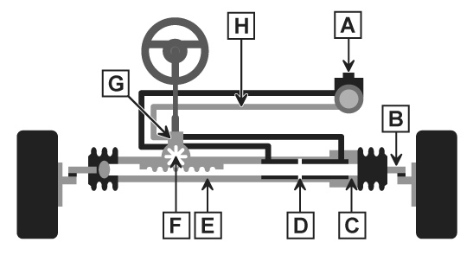
A
B
C
D
E
F
G
H

Draw a basic layout of the following 3 steering systems and compare the differences in construction and operation of each
Manual Steering | Comparison of Construction and Operation
Hydraulic Power Steering | Comparison of Construction and Operation
Electronic Power Steering | Comparison of Construction and Operation

Describe 2 different methods to test the operation of steering systems and components and the purpose of each test. Include how you would compare against manufacturer specification
System | Test method 1 | Test method 2
Manual steering
Hydraulic power steering
Electronic power steering

Give at least 3 examples of common Steering system faults and common causes for each
System | Fault 1 | Fault 2 | Fault 3
Manual steering
Hydraulic power steering
Electronic power steering

Identify the labelled light vehicle suspension system components below
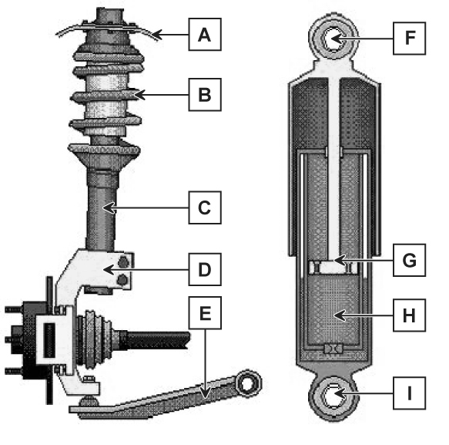

A
B
C
D
E
F
G
H
I

Draw a basic layout of the following 4 suspension systems and compare the differences in construction and operation of each
Independent Suspension | Comparison of Construction and Operation
Non-Independent Suspension | Comparison of Construction and Operation
Hydraulic Suspension | Comparison of Construction and Operation
Hydro-Pneumatic Suspension | Comparison of Construction and Operation

Describe 2 different methods to test the operation of suspension systems and components and the purpose of each test. Include how you would compare against manufacturer specification
System | Test method 1 | Test method 2
Independent suspension
Non-independent suspension
Hydraulic suspension
Hydro-pneumatic suspension

Give at least 3 examples of common suspension system faults and common causes for each
System | Fault 1 | Fault 2 | Fault 3
Independent suspension
Non-independent suspension
Hydraulic suspension
Hydro-pneumatic suspension
Independent suspension

Explain the following key engineering principles relating to steering and suspension systems
Principle | Explanation
Steering angles
Hydraulic forces
Stress and strains

Task 2 – Braking systems | Assessment Criteria 2.1, 2.2, 2.3, 2.4, 2.5, 4.2, 4.4

Identify the labelled light vehicle braking system components below
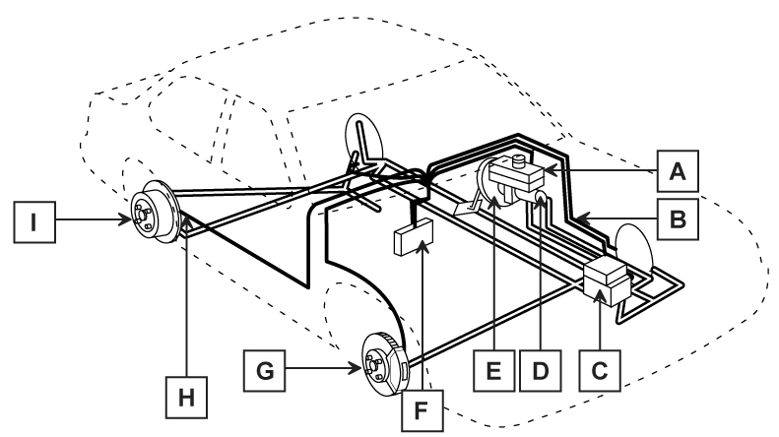

A
B
C
D
E
F
G
H
I

Draw a diagram of a light vehicle disc brake | Label Diagram | Explain their operation
 | 1
 | 2
 | 3
 | 4
 | 5
 | 6
 | 7

Draw a diagram of a light vehicle drum brake (twin or single leading shoe) | Label Diagram | Explain their operation
 | 1
 | 2
 | 3
 | 4
 | 5
 | 6
 | 7

Draw a diagram of a typical light vehicle electronic braking system layout | Label Diagram | Explain their operation
 | 1
 | 2
 | 3
 | 4
 | 5
 | 6
 | 7

From the systems above give 3 alternatives to compare against construction and operation (e.g. twin piston callipers)
Alternative System | Compare Construction and Operation
1.
2.
3.

Describe 3 different methods to test the operation of the following braking systems and the purpose of each test. Include how you would compare against manufacturer specification
System | Test method 1 | Test method 2 | Test method 3
ABS braking system
Non-ABS braking system
Give at least 3 examples of common braking system faults and common causes for each
System | Fault 1 | Fault 2 | Fault 3
ABS braking system
Non-ABS braking system

Explain the following key engineering principles relating to braking systems
Principle | Explanation
Laws of friction
Hydraulics
Pneumatics
Properties of fluids
Properties of air
Braking efficiency

Task 3 – Wheels and tyres | Assessment Criteria 3.1, 3.2, 3.3, 3.4, 3.5, 4.2, 4.4

Identify the labelled light vehicle tyre construction elements in the table below

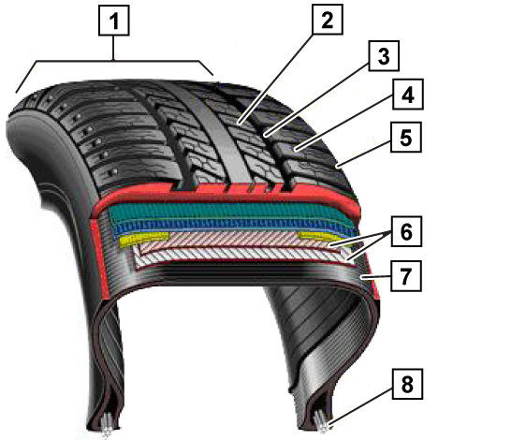
1
2
3
4
5
6
7
8

Identify the labelled parts of a steel wheel in the table below
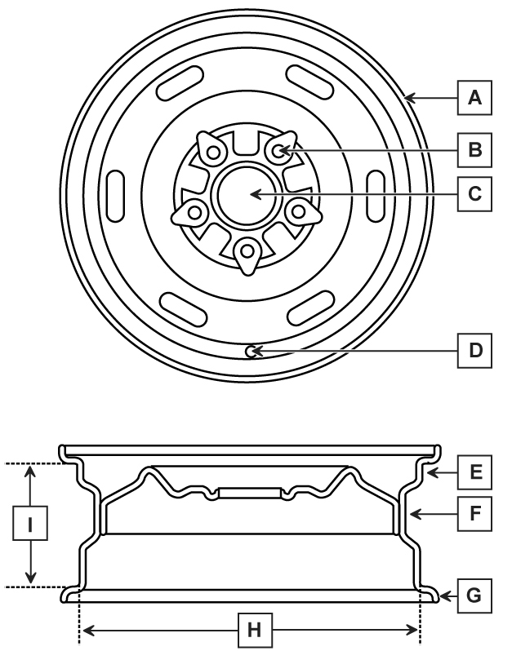
A
B
C
D
E
F
G
H
I

Draw a diagram showing the construction and operation of the following 3 types of tyre and compare their differences
Cross ply | Compare the Construction and Operation
Bias-belted | Compare the Construction and Operation
Radial | Compare the Construction and Operation

Describe the construction and operation of the following 3 types of wheel and compare their differences
Steel | Describe the Construction and Operation and compare their differences
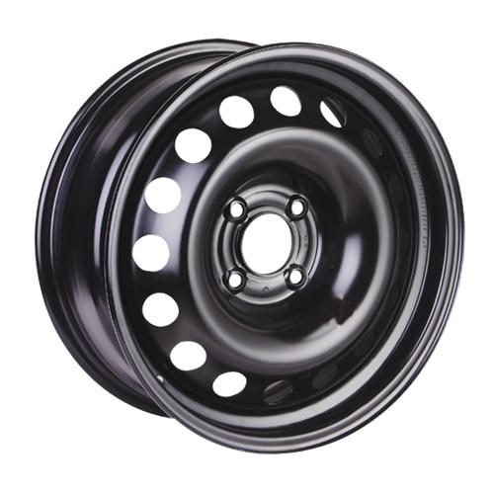
Alloy | Describe the Construction and Operation and compare their differences
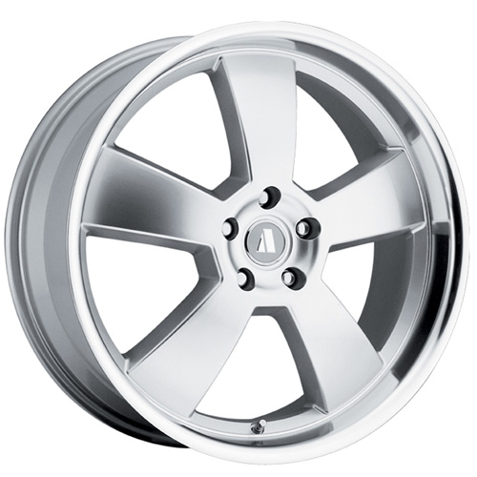
Wire | Describe the Construction and Operation and compare their differences
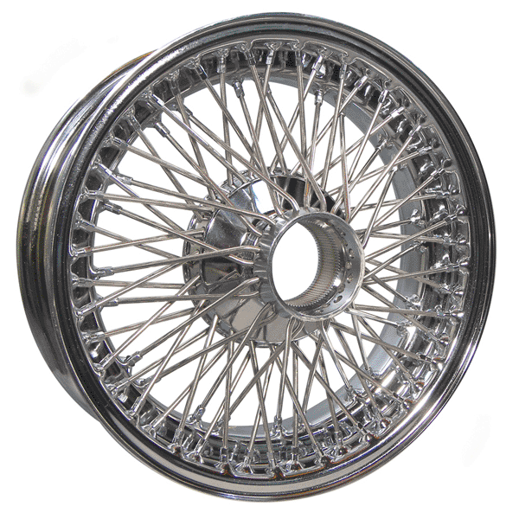

Describe 2 different methods to test the operation of the following wheels and tyres and the purpose of each test. Include how you would compare against manufacturer specification
System | Test method 1 | Test method 2
Cross ply
Bias-belted
Radial
Steel wheel
Alloy wheel
Wire wheel

Give at least 3 examples of common wheel and tyre faults and common causes for each
 | Fault 1 | Fault 2 | Fault 3
Cross ply
Bias-belted
Radial
Steel wheel
Alloy wheel
Wire wheel

Explain the following key engineering principles relating to wheels and tyres
Principle | Explanation
Friction
Un-sprung weight
Dynamic and static balance

Task 4 – Removing and replacing chassis units and components | Assessment Criteria 4.1, 4.3

Describe safe removal and replacement procedures of the following chassis units and components
Steering system
Suspension system
Braking system
Wheels
Tyres
Explain how to evaluate the performance of replacement units against vehicle specification

Unless otherwise stated e.g. for some entry level qualifications, learners can work together but should identify sections which are their own work.

